
DECRIPTION ON EXAUST FANS | WRITTEN BY:DEHYA KHURRAIM SIDDQUI & SAFDER REHMAN
FANoFAN | WALL FANS

Table of Contents

TURBO 180 ------------------------------------------------------3
MIST AIR ICY ------------------------------------------------------5
HELIX MEGA ------------------------------------------------------7
STRIKER HI-SPEED ------------------------------------------------------9
MAX AIR ------------------------------------------------------11
MAX AIR SUPER ------------------------------------------------------13
MIST AIR DOUS ------------------------------------------------------15
MIST AIR ICY ------------------------------------------------------17

Figures
Figure 1 3
Figure 2 5
Figure 3 7
Figure 4 9
Figure 5 11
Figure 6 13
Figure 7 15
Figure 8 19

TURBO 180

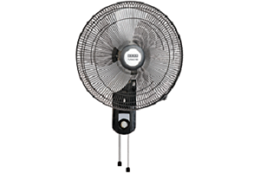
Figure 1
COLOUR: BLACK SPEED: 1330 RPM
SWEEP: 450 mm Power Input: 125 W Air Delivery: 125 M³/Min PRICE: RS 4750

KEY FEATURE:

RPM 1330 125 m³/h 450 MM

MIST AIR ICY

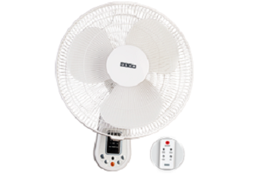
Figure 2
COLOUR: WHITE SPEED: 1280 RPM
SWEEP: 400 mm Power Input: 60 W
Air Delivery: 67 M³/Min PRICE: RS 3450

KEY FEATURE:
RPM 1280 67 m³/h 400MM

HELIX MEGA

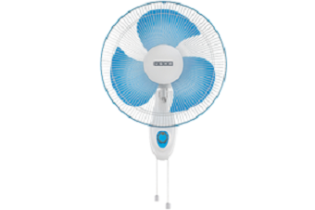
Figure 3
COLOUR: BLUE SPEED: 2200 RPM
SWEEP: 400 mm Power Input: 115 W
Air Delivery: 100 M³/Min PRICE: RS 2970

KEY FEATURE:
RPM 2200 100 m³/h 400MM

STRIKER HI-SPEED

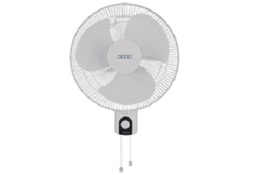
Figure 4
COLOUR: WHITE SPEED: 2000 RPM
SWEEP: 400 mm Power Input: 125 W
Air Delivery: 100 M³/Min PRICE: RS 2550

KEY FEATURE:
RPM 2000 100 m³/h 400MM

MAX AIR

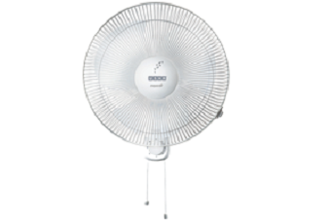
Figure 5
COLOUR: WHITE SPEED: 1280 RPM
SWEEP: 400mm Power Input: 55W
Air Delivery: 67 M³/Min PRICE: RS 2450

KEY FEATURE:
RPM 1280 67 m³/h 400MM

MAXX AIR SUPER

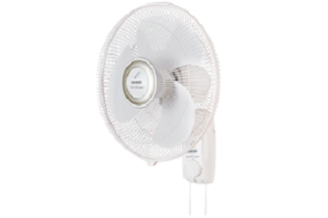
Figure 6
COLOUR: WHITE SPEED: 1280 RPM
SWEEP: 400mm Power Input: 55 W
Air Delivery: 67M³/Min PRICE: RS 2450

KEY FEATURE:
RPM 1280 67 m³/h 400MM

MIST AIR DOUS
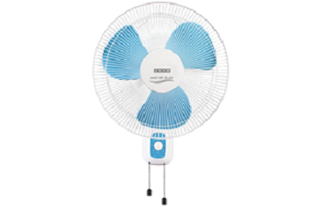

Figure 7
COLOUR: BLUE SPEED: 1280 RPM
SWEEP: 400 mm Power Input: 55 W
Air Delivery: 60 M³/Min PRICE: RS 2390

KEY FEATURE:
RPM 1280 60 m³/h 400MM

MIST AIR ICY

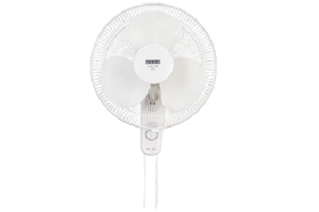
Figure 8
COLOUR: WHITE SPEED: 1280 RPM
SWEEP: 400 mm Power Input: 55 W
Air Delivery: 67M³/Min PRICE: RS 2390

KEY FEATURE:
RPM 1280 67 m³/h 400MM

WRITTEN BY

DEHYA KHURRAIM SIDDQUI : WEB DESIGNER
SAFDER REHMAN : WEB EDITOR

IN SUPPERVISION OF

MISS ALMAS.

WEBSITE LINK

